



Mercury API Specification
Processor – Credit Transfer Request Inbound from Client

Table of Contents
Confidentiality Notice: This document contains private information about Mercury (Pty) Ltd. You can't copy, reproduce, or share its product details, intellectual property, or design methods with anyone else unless you have our written consent.

1) Document Purpose 3
2) Process Flow 4
3) Mercury Credit Transfer Request Message From Client 6
4) Embedded Participant Message Structures 23

Document Purpose
The purpose of this document is to provide a detailed specification of the Credit Transfer Request call to be received by the Mercury Processor API from the Client (Mercury Client) as part of the Mercury Credit Transfer Process.

This document will focus on the Inbound Message from the Mercury Client to the Mercury Processor API and will indicate the processing to be completed before constructing the Credit Transfer Request message to be sent to the Host (Enterprise or External).

NOTE: Some of the values contained in the Outgoing Message Structure will be retrieved from the Configuration Settings that are specific to the Mercury Processor API for the specified Entity.

Process Flow
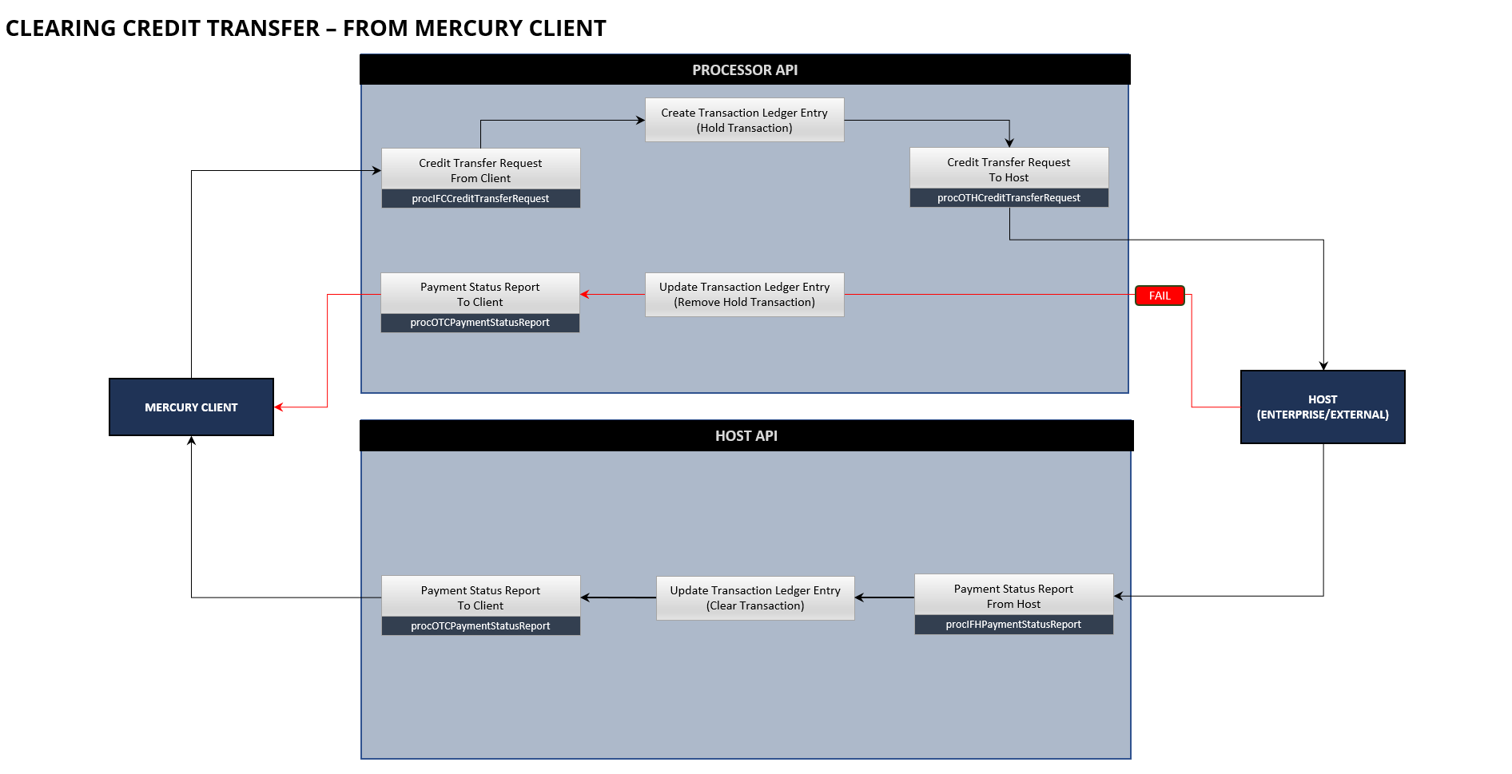

The Mercury Credit Transfer process flow indicated above is initiated on the Mercury Client and the request will be processed from the Mercury Client to the Mercury Processor API. After decryption and validation of the message by the Mercury Processor API, a Transaction Ledger Entry will be created (Hold) for the Transaction (Linked to the Client Transaction and Internal Mercury Reference) and then the Credit Transfer Request (Out to Host) message will be constructed and sent to the Host (Enterprise or External).

The response to the Mercury Client will be based on the decryption and validation results and sent to the Mercury Client before proceeding with the Transaction Ledger Entry, Out to Host Message construction and sending of the message to the Host (Enterprise or External).

If the request to the Host (Enterprise or External) was successful (indicated by a 200 HTTP Response), the request will be processed by the Host (Enterprise or External).

The Host (Enterprise or External) will send the response (Payment Status Report), as a separate message (Not as a response to the original Credit Transfer Request) based on the result of the processing of the Transaction. The Payment Status Report (In from Host) will be processed from the Host (Enterprise or External) to the Mercury Host API. After decryption and validation of the message by the Mercury Host API, the associated Transaction Ledger Entry will be Updated as Settled (Based on the Internal Mercury Reference) and then the Payment Status Report (Out to Client) message will be constructed and sent to the Mercury Client.
The response to the Host (Enterprise or External) will be based on the decryption and validation results and sent to the Host (Enterprise or External) before proceeding with the Transaction Ledger Entry Update, Out to Client Message construction and sending of the message to the Mercury Client.

Should the Mercury Credit Transfer Request to the Host (Enterprise or External) fail, the Mercury Processor API will, update the Transaction Ledger (set the Transaction as Failed) and then generated a Payment Status Report (Out to Client) indicating the reason and details for the failed transaction, to the Mercury Client.

Mercury Credit Transfer Request Message From Client

Overview
This Mercury Credit Transfer Request API is invoked during the processing of the Mercury Credit Transfer Request received from the Mercury Client.

Process Flow
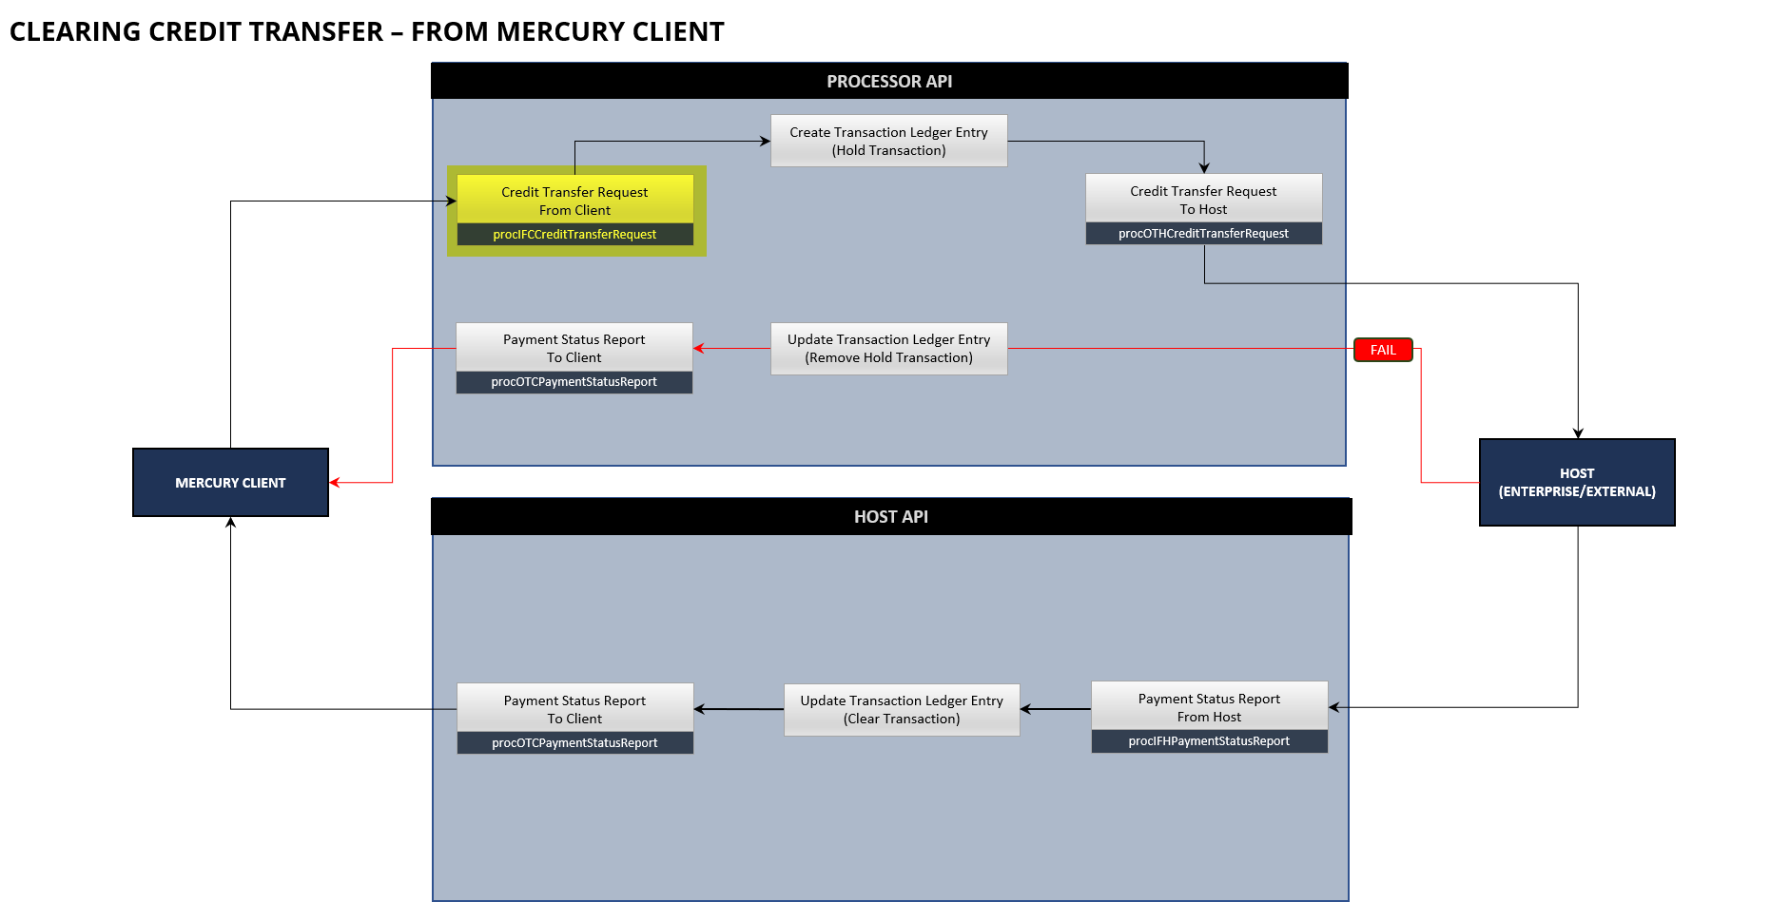
When receiving the Mercury Credit Transfer Request message from the Mercury Client for processing, the Mercury Processor API need to validate and respond to the Mercury Client, before creating the Transaction Ledger Entry and then initiating a separate Mercury Credit Transfer Request from the Mercury Processor API to the relevant Host (Enterprise or External).

As part of the basic API Processing the following steps need to be followed:

STEP | DESCRIPTION
1. | Store and Log the Message Request Details in the Message Request Detail table for auditing purposes.  Table Name: mrd_Message_Request_Detail
2. | Initialize the Credit Transfer Request (In From Client) Message Class with the details received in the API Call from the Mercury Client.  Message Class: procIFCCreditTransferRequest
3. | Validate the Secure Token contained in the Message against the content of the Credit Transfer Request Message received from the Mercury Client.  Error Response Code: ECL8070006
4. | Complete the following basic validations on the Message Class  - Field Types  Validate if the values received in the message are of the correct type as specified by the Message Class Structure.  Error Response Code: ECL8070001  - Field Lengths  Validate if the values received conform to the field lengths specified by the Message Class Structure.  Error Response Code: ECL8070002  - Required Fields  Validate if all the required fields have been received as specified by the Message Class Structure.  Error Response Code: ECL8070004  - Lookup Values  Validate that the values received in the message for the following fields exist in the Lookup Tables associated with them:  - Transaction Local Instrument Code  - Settlement Amount Currency  - Transaction Amount Currency  - Country Code  - Account Proxy Type  Error Response Code: ECL8070003  - Duplicates  Validate that the message received is not a duplicate. Base validation on the following fields:  - Source Transaction Identifier  - Message Request Type  - Subscriber ID  - HTTP Response Code (200 cannot already exist)  Error Response Code: ECL8070021
5. | Complete the following custom validations on the Message Class  - Creation Date Time  Ensure that the Creation Date Time value received conforms to the structure specified in the Message Class Structure.  Error Response Code: ECL8070003  - Source Transaction Identifier  Validate if the Transaction Identifier value is unique for the specific Payer Participant.  Error Response Code: ECL8070021  - UETR Structure  Validate if the UETR value conforms to the specification and structure of a UETR value.  Error Response Code: ECL8070003  - Local Instrument Code  Validate if the Local Instrument Code value conforms to the default value specified (PBPX or PBAC).  Error Response Code: ECL8070003  - Amount Structure  Validate if the Settlement Amount Structure and Instructed Amount (if populated) value conforms to the structure of an Amount value.  Error Response Code: ECL8070003  - Account Proxy Structure  If the Account Proxy Type is specified as MBNO, verify that the Account Proxy conforms to the structure specified the Message Class Structure.  Error Response Code: ECL8070003  - Email Address (if populated)  Validate if the Email Address populated conforms to a valid Email Address Structure.  Error Response Code: ECL8070003  - Payee Account Bank Identifier  Validate if the Party Account Bank Identifier (BICFI) exists and is a valid Bank Identifier (for Payee Account Details when populated for Pay-by-Account)  Error Response Code: ECL8070003  - Payee Account Details (CDV)  Complete a CDV Validation on the Payee Account Details (for Payee Account Details when populated for Pay-by-Account)  Error Response Code: ECL8070023  - Subscriber ID  Validate if the Subscriber ID exist on the Client API Configuration Table.  Table Name: cac_Client_API_Configuration  Error Response Code: ECL8070022
6. | If any of the validations have failed, respond to the Mercury Client with the appropriate Error Response Code and description of the error detected.  Use the Message Request Response structure.  The details of the response to the Mercury Client should also be logged against the Entry that was added to the Message Request Detail table.
7. | If any of the validations have passed, respond to the Mercury Client with the appropriate Error Response Code (Success).  Use the Message Request Response structure.  The details of the response to the Mercury Client should also be logged against the Entry that was added to the Message Request Detail table.
8. | After responding to the Mercury Client, Add the details of the validated Credit Transfer Request to the Transaction Ledger Detail table (tld_Transaction_Ledger_Detail) indicating a Status Code of Awaiting Settlement.
9. | The following values need to be created to be used in the construction of the Credit Transfer Request message to the relevant host:  - Message Identification  This value needs to be created as a unique Message Identification value based on the BICFI linked to the Subscriber ID received in the message from the client.  - Transaction Identifier  This will be a unique Transaction Identifier for the transaction in the Mercury System and will be used in the Message that is sent to the Host. This is NOT the Transaction Identifier received from the Mercury Client but will be used to link the Mercury Transaction created to the relevant Host System to the Transaction received from the Mercury Client.  - Source Participant Details  This will be based on the BICFI Code that is linked to the Subscriber ID  - Destination Participant Details  This will always be the Bankserv BICFI Code (BKSVZAJ0)  - Transaction Currency  This will be retrieved from the Configuration for the Subscriber ID indicating the Transaction Currency for the Subscriber (Default to ZAR)  The rest of the values needed for the Construction of the Credit Transfer Request to the Host (Enterprise, External or Payments Hub) can be retrieved from the Credit Transfer Request received from the Mercury Client.
10. | After the creating the Transaction Ledger Detail record, continue with the construction of the Credit Transfer Request (Out to Host) Message Class.  Message Class: procOTHCreditTransferRequest  NOTE:  The details of this Message Structure are contained in the Mercury – OTH - Credit Transfer Request specification document.
11. | Process the constructed Credit Transfer Request (Out to Host) Message to the Host (Enterprise, External or Payments Hub).  NOTE: The details of the Credit Transfer Request (Out to Host) should be logged in the Message Request Detail Table.

Message Requirements
DEVELOPMENT
ENDPOINT | https://payments-test.azurefd.net/api/beapiGlobalMercuryClientProcessor
HEADERS | x-beapiglobalmercuryclientprocessor-api-version  1.0.0-dev  Ocp-Apim-Subscription-Key  TBC  environment  LIVE  subscriberID  TBC

STAGING
ENDPOINT | https://payments-test.azurefd.net/api/beapiGlobalMercuryClientProcessor
HEADERS | x-beapiglobalmercuryclientprocessor-api-version  1.0.0-staging  Ocp-Apim-Subscription-Key  TBC  environment  LIVE  subscriberID  TBC

PRODUCTION
ENDPOINT | https://dt-apim-zan-prod-paymenthub.directtransact.co.za/api/beapiGlobalMercuryClientProcessor
HEADERS | x-beapiglobalmercuryclientprocessor-api-version  1.0.0  Ocp-Apim-Subscription-Key  TBC  environment  LIVE  subscriberID  TBC

Request
REQUEST DETAIL
ENDPOINT | {Processor Endpoint}/procIFCCreditTransferRequest
METHOD | POST

REQUEST BODY
CLASS NAME | clsIFCCreditTransferRequest
FIELD | DESCRIPTION
secureToken | Required  Unique encrypted value constructed from the field values contained in the message.  Format:  String
subscriberID | Required  Unique Subscriber ID that is issued by the Payment Hub to uniquely identify the source from where the call is received.  Format:  String  Example:  910
primaryHostReference | Required  Primary Reference Value to the Host (Enterprise or External) or to the Payment Hub to assist in identifying the Account on the Host (when sent to a Host). This value will be returned in messages from the Host or Payment Hub to assist in identification of the original transaction and routing details back to the Mercury Client.  Usage:  To Internal Host (Enterprise) – Populate with the Profile Id linked to the Account from where the Credit Transfer will be made from.  To External Host – Populate with Profile Identification on the External Host system to which the Account where the Credit Transfer will be made from, is linked to.  To Payment Hub – Populate with the Profile Identifier linked to the Account from where the Credit Transfer will be made from to enable Balance Enquiry API Call to a specific Host System.  Format:  String  Example:  2023083100001
secondaryHostReference | Required  Secondary Reference Value to the Host (Enterprise or External) or to the Payment Hub to assist in identifying the Account on the Host (when sent to a Host). This value will be returned in messages from the Host or Payment Hub to assist in identification of the original transaction and routing details back to the Mercury Client.  Usage:  To Internal Host (Enterprise) – Populate with the Account Number from where the Credit Transfer will be made from.  To External Host – Populate with Account Number on the External Host system from where the Credit Transfer will be made from.  To Payment Hub – Populate with the Account Number from where the Credit Transfer will be made from to enable Balance Enquiry API Call to a specific Host System.  Format:  String  Example:  78602467923
creationDateTime | Required  Creation Date Time of the request from the Payer Participant API.  Format:  String  yyyy-MM-ddThh:mm:ss.SSSSSS  Example:  2021-11-17T11:27:53.015708
transactionIdentifier | Required  Unique Identification value assigned by the Mercury Client, to unambiguously identify the transaction on the Mercury Client System. This identification is used to link the Transaction received from the Mercury Client to the Transaction that is to be processed by the Mercury Client Processor. This value will also be used to ensure the transaction is unique and will be used for duplicate validation.  Format:  String  Example:  54000000000000001
transactionUETR | Required  Universally unique identifier to provide an end-to-end reference of a payment transaction. Unique Identification value assigned by the Mercury Client (initiating the transaction to the Mercury Client API), to unambiguously identify the transaction. This identification is passed on, unchanged, throughout the entire end-to-end chain. Ensure that this value is stored separately to allow for validation if this value is unique. Ensure that this value is stored separately.  Format:  String  Pattern:  [a-f0-9]{8}-[a-f0-9]{4}-4[a-f0-9]{3}-[89ab][a-f0-9]{3}-[a-f0-9]{12}  Example:  f22dd32f-07db-488b-b648-dab6b3ffc4ef
transactionType | Required  Specifies the Credit Transfer Transaction Type. This indicates the Type of Credit Transfer Request (Pay by Proxy or Pay by Account) for this Credit Transfer Request.  Format:  String; max length 35 characters.  Restrictions:  Must be one of the following values:  PBPX (Pay by Proxy)  PBAC (Pay by Account)  Example:  PBPX
transactionAmount | Required  Amount of the Credit Transfer Transaction.  Format:  Number (Fraction Digits: 2; Total Digits: 18; Minimum Inclusive: 0 – Value must be greater or equal to 0)  Example:  100.00
transactionReference | Required  User Defined Reference to be passed in the transaction.  Format:  String  Example:  Michael Pay Back
payerDetails | Required  The Details of the Party making the Credit Transfer Request.  A Party Detail structure.
payerAccountDetail | Required  The Account Details of the Party making the Credit Transfer Request.  A Party Account Detail structure.
payeeDetails | Required  The Details of the Party to whom the Credit Transfer Request is made to.  A Party Detail structure.
payeeAccountDetail | Required  The Account Details (Account Detail or Proxy Details) of the Party to whom the Credit Transfer Request is made to.  A Party Account Detail structure.

Response
API responses will return HTTP status code in the 2xx range. The response body will contain the response of the API as described in this specification.
RESPONSE
CLASS NAME | clsMessageRequestResponse
FIELD | DESCRIPTION
messageIdentification | Required  Unique Message Identification for the Message Request for which this response structure is created.  Format:  String: alphabetic, numeric, and underscores (_), e.g. spaces are not allowed; max length 35 characters.  YYYYMMDD_XXXX_TTTTT_SSS999999999999  YYYYMMDD - Date the message is created  XXXX – First 4 characters of the senders BICCode  TTTTT – Service Code  SSS – Unique Subscriber ID  999999999999 – 12-digit sequence number (for the current day – reset after day)  Example:  2021117_SASF_CRTRF_90200000001
messageResultDetail | Required  A Message Result structure.

Response Codes
Internal Response Codes available for the Message Request Response are listed below. The Response Codes will have a format of ECLABBCCCC and is compiled as follows:

ECL Fixed value for the Response Code Prefix
A Service Indicator where 8 will indicate the Processor API and 9 will indicate the Host (Enterprise, External or Payments Hub) as the origin of the response.
BB Message Type Indicator (2 digits) where 07 will indicate the Credit Transfer Request Message Type.
CCCC Unique value per Response indicating a unique Response.

RESPONSE CODES
HTTP STATUS | RESPONSE CODE | RESPONSE DESCRIPTION
200 | ECL8070000 | SUCCESS
200 | ECL8070001 | ERROR_INVALID_FIELD_TYPE
200 | ECL8070002 | ERROR_INVALID_FIELD_LENGTH
200 | ECL8070003 | ERROR_INVALID_FIELD_VALUE
200 | ECL8070004 | ERROR_REQUIRED_DATA_MISSING
200 | ECL8070005 | ERROR_INTERNAL_SYSTEM_ERROR
200 | ECL8070006 | ERROR_CRYPTOGRAPHY
200 | ECL8070021 | ERROR_DUPLICATE_TRANSACTION
200 | ECL8070022 | ERROR_INVALID_SUBSCRIBER_ID
200 | ECL8070023 | ERROR_PAYEE_ACCOUNT_DETAILS_CDV_FAILED

Sample Request
{
"secureToken": "string",
"subscriberID": "string",
"primaryHostReference": "string",
"secondaryHostReference": "string",
"creationDateTime": "string",
"transactionIdentifier": "string",
"transactionUETR": "string",
"transactionType": "string",
"transactionAmount": 0,
"transactionReference": "string",
"payerDetails": {
"partyName": "string",
"partyIdentification": {
"partyOrganisationIdentification": "string",
"partyPrivateIdentification": "string"
},
"partyCountryOfResidence": "string",
"partyAddressDetail": {
"partyAddrStreetName": "string",
"partyAddrStreetNumber": "string",
"partyAddrBuilding": "string",
"partyAddrFloor": "string",
"partyAddrSuburb": "string",
"partyAddrCity": "string",
"partyAddrProvince": "string",
"partyAddrCountry": "string",
"partyAddrPostalCode": "string"
},
"partyContactDetail": {
"partyMobileNumber": "string",
"partyEmailAddress": "string"
}
},
"payerAccountDetail": {
"partyAccountIdentification": "string",
"partyAccountType": "string",
"partyAccountBank": "string",
"partyAccountName": "string",
"partyProxy": "string",
"partyProxyType": "string"
},
"payeeDetails": {
"partyName": "string",
"partyIdentification": {
"partyOrganisationIdentification": "string",
"partyPrivateIdentification": "string"
},
"partyCountryOfResidence": "string",
"partyAddressDetail": {
"partyAddrStreetName": "string",
"partyAddrStreetNumber": "string",
"partyAddrBuilding": "string",
"partyAddrFloor": "string",
"partyAddrSuburb": "string",
"partyAddrCity": "string",
"partyAddrProvince": "string",
"partyAddrCountry": "string",
"partyAddrPostalCode": "string"
},
"partyContactDetail": {
"partyMobileNumber": "string",
"partyEmailAddress": "string"
}
},
"payeeAccountDetail": {
"partyAccountIdentification": "string",
"partyAccountType": "string",
"partyAccountBank": "string",
"partyAccountName": "string",
"partyProxy": "string",
"partyProxyType": "string"
}
}

Sample Request Message
{
"secureToken": "07ac3cf0add872d8af56e2ac62213b9add6a4fb61977e1fe109c54dda67c1c48",
"subscriberID": "910",
"primaryHostReference": "2023083100001",
"secondaryHostReference": "78602467923",
"creationDateTime": "2023-10-03T11:27:53.015708",
"transactionIdentifier": "1A66C164-0EDA-4170-8D13-FBF9E495B680",
"transactionUETR": "a1182b47-12ec-3655-8a94-8bb3d95bea55",
"transactionType": "PBAC",
"transactionAmount": 100.00,
"transactionReference": "Micheal Block 230930",
"payerDetails": {
"partyName": "King Price Gauteng"
},
"payerAccountDetail": {
"partyAccountIdentification": "78602467923",
"partyAccountType": "1",
"partyAccountName": "King Price Gauteng"
},
"payeeDetails": {
"partyName": "Micheal Block",
"partyIdentification": {
"partyPrivateIdentification": "7001012293083"
},
"partyContactDetail": {
"partyMobileNumber": "+27-717654321",
"partyEmailAddress": "michealb@kingprice.co.za"
}
},
"payeeAccountDetail": {
"partyAccountIdentification": "1268602123",
"partyAccountType": "2",
"partyAccountBank": "ABSAZAJJ",
"partyAccountName": "Micheal Block"
}
}

Sample Response
{
"messageRequestID": "string",
"messageResultDetail": {
"resultCode": "string",
"resultDescription": "string",
"resultMessage": "string",
"transactionIdentifier": "string",
"processingTransactionId": "string"
}
}

Sample Response Message Success
{
"messageRequestID": "20231003_SASF_CRTRF_910000000000001",
"messageResultDetail": {
"resultCode": "ECL8070000",
"resultDescription": "SUCCESS",
"resultMessage": "",
"transactionIdentifier": "1A66C164-0EDA-4170-8D13-FBF9E495B680",
"processingTransactionId": "CAE4F68F-BFB1-4FB2-B2B0-4AA94096142E"
}
}

Sample Response Message Error
{
"messageRequestID": "20231003_SASF_CRTRF_910000000000001",
"messageResultDetail": {
"resultCode": "ECL9070015",
"resultDescription": "ERROR_REQUIRED_DATA_MISSING",
"resultMessage": "The Message Identifier field is required.",
"transactionIdentifier": "1A66C164-0EDA-4170-8D13-FBF9E495B680"
}
}

Embedded Participant Message Structures

Party Detail
Note: This structure is used in various Message Request Structures in the Client and Host API’s.

MESSAGE RESULT
CLASS NAME | clsPartyDetail
FIELD | DESCRIPTION
partyName | Required  The Name by which the Party is known. This can include the Surname if so received.  Format:  String: max length 70 characters.  Example:  Micheal
partyIdentification | Optional  Identification information for the party. If populated, either Organizational or Private Identification must be provided.  A Party Identification structure.
partyCountryOfResidence | Optional  Country in which the Party resides (the place of a party’s home). In the case of a company, it is the country from which the affairs of that company are directed.  Format:  String  Example:  South Africa
partyAddressDetail | Optional  Information that locates and identifies a specific address, as defined by postal address.  A Party Address Detail structure.
partyContactDetail | Optional  Set of elements used to indicate how to contact the party.  A Party Contact Detail structure.

Party Identification
Note: This structure is used in various Message Request Structures in the Client and Host API’s.

MESSAGE RESULT
CLASS NAME | clsPartyIdentification
FIELD | DESCRIPTION
partyOrganisationIdentification | Optional  Unique or unambiguous way to identify an organization.  Format: String; max length 35 characters.
partyPrivateIdentification | Optional  Unique or unambiguous identification of a person, for example a passport.  Format: String; max length 35 characters.

Party Address Detail
Note: This structure is used in various Message Request Structures in the Client and Host API’s.

MESSAGE RESULT
CLASS NAME | clsPartyAddressDetail
FIELD | DESCRIPTION
partyAddrStreetName | Optional  Party Address Street Name  Format: String: max length 70 characters.  Example:  Ross Road
partyAddrStreetNumber | Optional  Party Address Street Number  Format: String: max length 16 characters.  Example:  2
partyAddrBuilding | Optional  Party Address Building or Complex Name  Format: String: max length 35 characters.  Example:  Hill Crest
partyAddrFloor | Optional  Party Address Floor  Format: String: max length 70 characters.  Example:  2nd Floor
partyAddrSuburb | Optional  Party Address Suburb  Format: String: max length 35 characters.  Example:  Roodeport
partyAddrCity | Optional  Party Address City  Format: String: max length 35 characters.  Example:  Johannesburg
partyAddrProvince | Optional  Party Address Province  Format: String: max length 35 characters.  Example:  Gauteng
partyAddrCountry | Optional  Party Address Country  Format: String: [A-Z]{2,2}  Example:  ZA
partyAddrPostalCode | Optional  Party Address Country  Format: String: max length 16 characters.  Example:  2120

Party Contact Detail
Note: This structure is used in various Message Request Structures in the Client and Host API’s.

MESSAGE RESULT
CLASS NAME | clsPartyContactDetail
FIELD | DESCRIPTION
partyMobileNumber | Optional  Party Mobile Number  Format: String; \+[0-9]{1,3}-[0-9()+\-]{1,30}  Example:  +27-717654321
partyEmailAddress | Optional  Party Email Address  Format: String: max length 2048 characters.  Example:  mrodgers@gmail.com

Party Account Detail
Note: This structure is used in various Message Request Structures in the Client and Host API’s.

MESSAGE RESULT
CLASS NAME | clsPartyAccountDetail
FIELD | DESCRIPTION
partyAccountIdentification | Conditional  Unambiguous identification of the account of the debtor/creditor to which a debit/credit entry will be made because of the transaction. Traditional Account Number or proxy SOV.  Required for payerAccountDetail structure as this will specify the Account Number from where the Credit Transfer is made from.  Required for payeeAccountDetail structure when the transactionLocalInstrumentCode is PBAC and then this will be the Account Number for the Payee.  Optional for any other conditions not mentioned above.  Format: String; max length 34 characters.  Example:  8200071250112
partyAccountType | Conditional  The type of the Account Number specified. Depending on where the Message is destined for (Internal Host, External Host or Payments Hub) and whether this is part of the payerAccountDetail or payeeAccountDetail.  Usage:  Required for payerAccountDetail structure when the message is destined for an Internal Host (Enterprise) in which case it should correspond to the ISO Standard Account Types (to be validated).  Required for payeeAccountDetail structure when the transactionLocalInstrumentCode is PBAC, in which case it should correspond to the ISO Standard Account Types (to be validated) and is also required for CDV Validation on Payer Account Details.  Optional for all other scenarios  Format:  String; max length 4 characters.
partyAccountBank | Conditional  The Bank BICFI associated with the Account. Depending on where the Message is destined for (Internal Host, External Host or Payments Hub) and whether this is part of the payerAccountDetail or payeeAccountDetail.  Usage:  Not Required for payerAccountDetail structure.  Required for payeeAccountDetail structure when the transactionLocalInstrumentCode is PBAC, in which case it should be a valid Bank BICFI Code (to be validated on Mercury Processing System) and required for CDV Validation on Payer Account Details.  Optional for all other scenarios  Format:  String  Pattern:  [A-Z0-9]{4,4}[A-Z]{2,2}[A-Z0-9]{2,2}([A-Z0-9]{3,3}){0,1}  Example:  SASFZAJJ
partyAccountName | Required  Account Name associated with the Account.  Format: String; max length 70 characters.
partyProxy | Conditional  Required for payeeAccountDetail structure when the transactionLocalInstrumentCode is PBPX and then this will be the Proxy Identifier for the Payee.  Format: String; max length 2048 characters.  \+[0-9]{1,3}-[0-9()+\-]{1,30}  NOTE:  If Proxy Type is MBNO, pattern needs to be validated.  If Proxy Type is CUST, length needs to be validated.  Example:  +27-812456789
partyProxyType | Conditional  Required for payeeAccountDetail structure when the transactionLocalInstrumentCode is PBPX and then this will be the Proxy Type for the Payee.  Format: String; max length 4 characters.  It is one of the following values:  - MBNO  - CUST

Message Result
Note: This structure is used in various Message Request Structures in the Processor and Participant API to and from the Participant API.

MESSAGE RESULT
CLASS NAME | clsMessageResult
FIELD | DESCRIPTION
resultCode | Required  Appropriate Response Code for the Message Type  Format: String; length 10 characters.
resultDescription | Required  Appropriate Response Description for the Message Type  Format: String; max length 50 characters.
resultMessage | Optional  Additional Response Detail associated with the Response Code and Description (Example: Field Name that failed the validation)  Format: String; max length 256 characters.
transactionIdentifier | Required  This will be the Transaction Identifier received from the Mercury Client for the Credit Transfer Request received by Mercury.
processingTransactionId | Conditional  Based on whether the Credit Transfer Request was accepted by the Mercury System that received the request, return the Mercury Transaction Id that was assigned for the request.

